CI517 - Game Engine Fundamentals Report, FN170

Student Declaration
I declare that my use of Generative AI tools is permitted under the assignment’s RAG rating (amber or green). Where appropriate I have checked the accuracy and bias of any outputs generated by Generative AI tools. By submitting this assignment, I acknowledge that I am responsible for any work presented.
I acknowledge use of Generative AI tools in the following areas:
Area where generative AI has been used  See example activities in each area on BSSH website | What tool did you use and what did you use it for? Include prompts if required by your assessment brief  Example: Preparation – Used Copilot to get ideas of suitable report structures. Prompt : “I am a third year undergraduate student in the UK, suggest a suitable outline structure for a research project report”
Assessment planning  e.g. time management | ChatGPT was used help interpret weekly lab tasks, clarifying exercise requirements and breaking the CI517 project into manageable development stages.  Example Prompt “Explain what Week 3 requires for input handling in SDL”.
Preparation  e.g. explaining terminology, exploring background | ChatGPT assisted in explaining SDL2 concepts such as event polling, delta time, movement logic and collision detection. No external sources were generated, all cited references were manually researched.
Research, note taking and organising ideas  Eg initial research, explaining source material | AI was used to assist with summarising and organising design ideas during early development, including the modular class structures, subsystem separation and update loop design. These summaries were used as planning aids only. All technical implementation decisions were made and validated through manually.
Writing  e.g. drafting, transforming content | ChatGPT supported the drafting and improving of clarity for descriptive explanation of engine components (Engine, Sprite, GameObject, InputManager, PlayerCharacter). All final written content was reviewed, edited and rewritten by me to ensure accuracy and consistency with the implemented code.
Editing and revision  Eg feedback on structure | ChatGPT provided structure and guidance on improving academic tone, improving transitions between sections.
Proofreading  e.g. correct spelling and grammar | Used for grammar and clarity improvements.
Calculations, data handling and coding  e.g. analysis of data | Used only for conceptual help. Understanding how to structure subsystems, fix logic errors and plan features (collision response, level loading, projectile cooldowns). All final code was implemented, adapted and debugged by me, No AI generated code was copied directly without modification and full understanding.
Creation of visuals  e.g. image generation | No AI image generation used. All Diagrams (annotated screenshots) were created by me.
Other  Anything that does not fit in the areas above | No additional generative AI uses beyond states areas.

Introduction & Project Scope: 2
Design Principles and Architectural Planning: 2
Conceptual Responsibilities Breakdown: 4
Initial Development Goals: 4
Conceptual Class Architecture Overview: 4
Initial Engine Architecture and Learning Outcomes: 5
Low Level Engine: 5
Engine: 5
Main Loop & Delta Time System: 6
Game Class / Scene Controller: 8
Sprite System: 8
GameObject System: 10
PlayerCharacter & Movement System: 10
Xcube2D Framework: 10
Implementation: 10
Critical Review: 10
Conclusion: 10
Estimated Grade: 10
References: 10

Introduction & Project Scope:
This report documents the design and implementation of a game engine subsystem developed using C++ within the Xcube2d framework. Rather than building a complete engine from scratch, the project focuses on extending an existing engine architecture by designing, integrating, and validating a modular audio subsystem alongside supporting gameplay systems.
The links provided are a video showcase explaining the reasoning and rationale behind each system, and a GitHub link for the repository.
YouTube: https://www.youtube.com/watch?v=uijLmx7vlhM
GitHub Links:
- https://github.com/Finnix14/CI517_Game_Engine_Fundamentals (SDL2 Weeks 1-8)
- https://github.com/Finnix14/CI517_Game_Engine_Fundamentals_Xcube2D_Framework (SDL2 xCube2D Framework Assessment Project)

Design Principles and Architectural Planning:
This modular structure follows best practices for SDL based engine architectures, where functionality is separated into clearly defined systems rather than large single files. As discussed on the GameDev Stack Exchange (2016), maintaining modular boundaries between engine components and gameplay logic improve the extendibility and reduces the coupling in SDL projects.
Similarly, Ullman et al. (2024) highlight that clear separation between core engine system and higher level gameplay subsystems significantly improve the long term maintainability of the project and helps to prevent overlapping responsibilities as the project scales.
High level overview of the class and system architecture used in the project. Core engine functionality is provided by the Xcube2D framework, while gameplay logic and subsystems are implemented by the user within the existing engine structure.
These principles informed how the existing Xcube2D engine architecture was utilised and extended during the development. Rather than reimplementing the core engine functionality, this project focuses on designing and integrating a new gameplay level subsystem that works coherently with Xcube2D’s modular structure. This supports the use of distinct classes such as; “Game”, “GameObject”, “Sprite”, and subsystem specific classes while respecting the boundaries of the engine pulling the strings.
Practical SDL implementation patterns were also informed by the Lazy Foo’ SDL tutorials, particularly the handling of event polling, frame updates and structural system responsibility separation (Lazy Foo 2019)
Within this structure, Xcube2D’s provided input handling system is utilised to abstract user input and state management while custom gameplay classes extend the base “GameObject” class to implement movement and interaction logic using delta time. Communication between the system is handled through clean references such as pointers passed during initialisation, rather than static dependencies. This approach maintains engine integrity while improving the future expansion

Conceptual Responsibilities Breakdown:
The system is divided into several key components:
- Engine – responsible for initialisation, rendering, updating and scene cleanup.

- Game – acts as the game manager, handles scene setup, object creation and manages collection of active GameObjects.

- InputManager – Handles event polling, key press/hold/release logic and directional axis (x,y).

- Sprite – manages individual textures, positions.

- Main – entry file that instantiates and runs the engine.

- GameObject – represents an entity in the game world, it manages positional data, velocity and behaviour (movement, collision).

- PlayerCharacter – a derived class which implements input based movement and rotation.

Initial Development Goals:
Development began with configuring SDL2 to work with Visual Studio, then confirming whether the libraries had linked, the first prototype. Was to create a project which could load a window using SDL’s initialisation methods.
Resources and guidance handed out by David Dorrington, helped in this task, and a prototyped SDL2 project with a functioning opening window was created. Helping to create a solid foundation.

Conceptual Class Architecture Overview:

Initial Engine Architecture and Learning Outcomes:
Prior to adopting the Xcube2D framework, an initial low level engine architecture was explored using C++ and SDL2. This early implementation was not intended as the final submitted system, but to develop familiarity with core responsibilities such as lifecycle management, update loops, rendering flow and subsystem separation.
A central “Engine” Class coordinated initialisation, the main loop, and shutdown reinforcing the importance of isolating platform specific logic from gameplay systems. The update loop followed a conventional structure; input, update, render, present. Which reflects patterns seen similarly in engines such as Unity or Unreal. Early implementation with fixed frame delay was later replaced by a delta time approach using “SDL_GetTicks()”, highlighting the importance of frame rate independent behaviour in real time applications.
Gameplay logic was progressively separated from engine level responsibilities through the introduction of a “Game” class which was responsible for managing entities through per frame updates. Input handling was abstracted into a dedicated “InputManager”, replacing direct SDL polling and enabling clearer separation of responsibilities. This system utilised “std::unordered_map” for efficient key state access, which is suitable for real time input polling due to its constant time average lookup performance (CPPreference, 2025).
Rendering responsibilities were encapsulated within a “Sprite” abstraction, while a base “GameObject” class grouped shared entity data such as position, velocity and dimensions. This abstraction reinforced modular design principles and reduced coupling between gameplay logic and rendering systems.

Low Level Engine:
This section summarises key architectural concepts that were explored during early low level development, included to contextualise the design decisions applied later within the Xcube2D framework.

Engine:
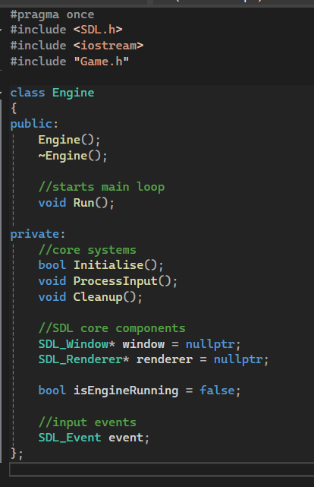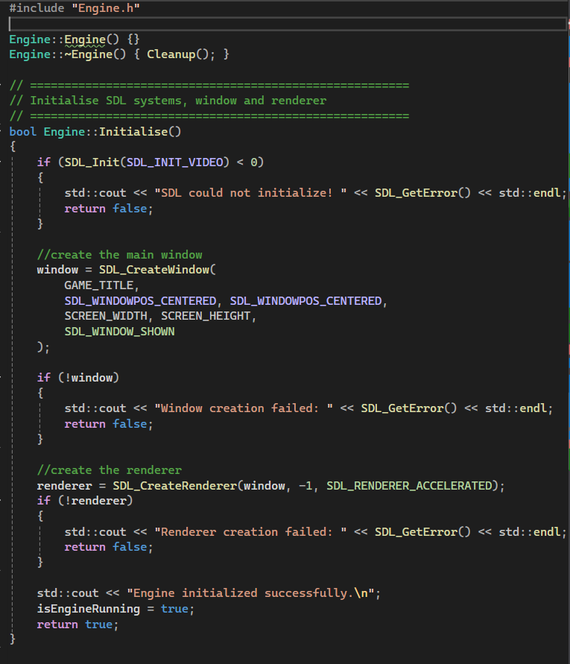
During early low level engine exploration, a central Engine abstraction was used to understand how real time systems typically coordinate initialisation, updates and shutdown. This design helped illustrate the value of centralising control flow and separating the engine level responsibilities from the gameplay logic.
In this previous structure, the engine acted as an orchestrator for the main loop, forwarding update calls to a higher level Game controller, which in turn managed active entities. Although this architecture is not used directly in the final submission, it informed later work by clarifying the responsibilities and the boundaries that are handled internally by the Xcube2D framework.

Main Loop & Delta Time System:
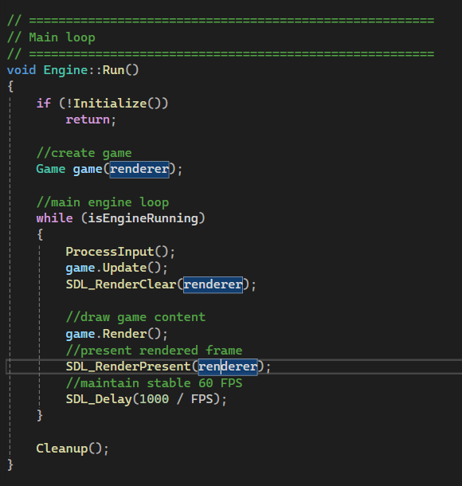
During early development, a fixed time step approach was firstly used to regulate the frame updates. However, this method introduced inconsistencies within movement when frame timing fluctuated. To address this issue, the update loop was restructured to use a delta time calculation based on elapsed frame time, ensuring more stable and frame rate independent motion.
Understanding and implementing the delta time handling was an important learning outcome, as this approach reflects the update models used by modern engines such as Unity or Unreal, which follow a structured loop of: Input Processing, State updates, Rendering and Presentation. This knowledge directly informed later work within the Xcube2D framework, where timing and update consistency are handled at the engine level.
This approach aligns with recommended SDL development practices such as those demonstrated in Lazy Foo’s Lesson 11, which emphasises the update flow and frame independence in real time SDL applications (Lazy Foo, 2019).

Game Class / Scene Controller:
During the low level engine exploration phase, a dedicated game abstraction was introduced to better understand how gameplay logic can be separated from engine level responsibilities. This structure acted as a conceptual scene controller, responsible for coordinating per frame updates across active entities rather than embedding gameplay logic directly within the engine loop.
Refactoring the entity update logic out of the engine highlighted the benefits of clearer responsibility boundaries between engine coordination and gameplay behaviour. This separation improved the code clarity and reinforced the object oriented design (OOP) principles, which later informed how gameplay logic was structured when working within the Xcube2D framework.
Basic movement and collision behaviour was explored at this stage to validate the update flow and entity interaction. Simple screen bound collision responses were sufficient for the purpose and were intentionally kept minimal, which served as a learning exercise rather than a fully featured collision system.

Sprite System:
The Sprite class was designed as a lightweight abstraction around texture rendering, its primary responsibility was to encapsulate texture loading, sizing and draw calls, reducing the direct dependency on SDL rendering code within the gameplay's logic.
This abstraction helped establish a clear separation between visual representation and game behaviour. Although Xcube2D later provides its own rendering pipeline, this early subsystem informed how sprites should be treated as interchangeable visual components rather than tightly coupled rendering logic.
Early sprite handling experiments were also influenced by Lazy Foo examples, which helped to reinforce the importance of isolating the rendering logic from the gameplay behaviour. (Lazy Foo, 2019)

GameObject System:
The GameObject system acted as the core of the entity abstraction within the prototype engine. Each GameObject stored positional data, velocity, dimensions and a reference to a visual representation. This structure allowed gameplay logic to operate independently of rendering implementation.
Introducing a unified GameObject layer helped reinforce the OOP design principles common in modern engines, where entities encapsulate state and behaviour while remaining decoupled from engine level subsystems. These clear principles directly informed the later use of Xcube2D’s object and update model.

PlayerCharacter & Movement System:
A specialised PlayerCharacter class was introduced to extend the base GameObject behaviour. This allowed player control logic to remain separate from generic entity behaviour while still benefitting from shared update and transform logic.
While this system was initially prototyped in the low level engine, its design translated into the final Xcube2D implementation, where player movement and state handling were implemented as a gameplay subsystem rather than part of the engine core.

Xcube2D Framework:
The architectural principles explored during the low level development, informed the transition to the Xcube2D framework. This provided clearer separation of responsibilities and boundaries for subsystem abstraction. So rather than reimplementing these systems, Xcube2D provides stable engine level services for rendering, input and timing. Allowing development to focus purely on integrating gameplay level subsystems while applying the same foundational design principles.
SCREENSHOT OF THE XCUBE2D GAMEPLAY FLOW
UML CLASS DIAGRAM OF MYENGINESYSTEMS RELATIONSHIP WITH THE XCUBE2D FRAMEWORK
The audio subsystem is designed to integrate within the Xcube2d engine as a managed engine-level service rather than a gameplay component. This aligns with earlier systems that were created as they were separate to gameplay logic and were clear in separation between engine systems and gameplay logic to improve the maintainability, modularity and the overall scalability of the project as it progressed. By following the same structural flow that the low-level learning taught, the audio subsystem inherits the benefits of reduced coupling, controlled responsibility boundaries and predictable system ownership.
This UML diagram illustrates that the engine owns and manages the lifecycle of the audio subsystem, which reinforces composition rather than external or static dependencies. This approach ensures that the subsystem can be initialised, updated and cleaned up consistently with the other engine subsystems. All this while preventing gameplay code from directly managing the core engine resources. Communication between the gameplay layer and the subsystem is handled through a controlled interface, allowing the audio functions such as music playback to be layered with sound effects and state changes to be performed without exposing the internal implementation breaking the encapsulation.
This design also supports future expansion. Because the subsystem exists as a distinct class set (.cpp, .h) rather than embedded logic, additional features such as audio layering, priority handling, environment based mixing, or event driven effects can be introduced without restructuring the engine. The subsystem therefore follows the same modular design philosophy applied in earlier engine design. Each system performs a clear role, interacts through defined boundaries and remains independent where possible while still being fully integrated as the engine level.
With these responsibilities and relationships defined, the next staged involved implementing the subsystem so that it operates as a self contained, engine driven system. Whilst maintaining a straightforward interface for gameplay code to interact with.

Implementation:
SCREENSHOT OF SOLUTION EXPLORER AND WHERE MY ENGINE SUBSYSTEM LIVES
This screenshot demonstrates where the custom audio subsystem lives within the engine's architecture. Rather than existing as isolated gameplay code, the subsystem is embedded at the engine level alongside the core systems involved such as rendering and input. This helps to reinforce that the solution is designed as a reusable engine component rather than a single file project feature. Placing the subsystem here allows for the engine to fully control its lifecycle and manage its initialisation and cleanup. This prevents any resource leaks and ensures consistent behaviour across any future projects.
SCREENSHOT OF AUDIO LAYER STRUCT
The Audio Layer struct encapsulates the key responsibilities required for the layered sound management to flow correctly. This includes, volume control, muting and state tracking. Instead of directly manipulating the raw SDL mixer values everywhere in the codebase, this abstraction centralises all the audio state logic, which reduces the duplication across the project and maintains it better as well. Designing the audio around layers also mirrors real engine practice (e.g, music, UI, sounds, SFX, environment), meaning the system is scalable rather than hard coded for a single use.
SCREENSHOT OF AUDIO ENGINE LAYERS FOR MULTIPLE AUDIO OUTPUT
This screenshot demonstrates how the subsystem supports multiple parallel audio outputs through distinct layers rather than a single global sound channel. Each layer is responsible for a logical category of audio such as UI, gameplay, SFX, music or ambience. Which allows for independent volume control and muting. This approach mirrors the real world engine practices and ensures the project maintains it reusability, manageability and scales so it is not limited to be a single hard coded behaviour but instead a reusable extensible component suitable for multiple game contexts.
SCREENSHOT OF METHODS TO CREATE LAYERS AND CHECK IF A LAYER EXISTS
These functions handle the safe creating and lookup of the audio layers within the subsystem. Attempting to play audio through an invalid or non existent layer could lead to crashes or undefined behaviour, to counter the system performs validation at every step. This demonstrates defensive programming and robustness. Two expectations of the engine level systems that are being designed. It also ensures the subsystem can be reused confidently without requiring the user to constantly perform manual checks.
SCREENSHOT OF AUDIO LAYER CLAMPING AND MUTING
This section shows how the subsystem ensures the volume remain within the valid limits and how muting is handled at a layer level rather than per sound. Implementing clamping prevents incorrect volume values from causing distortion or runtime issues, while a layer based approach for mute control allows entire categories of sounds to be disabled instantly. This reflects the real production of engine design, where the system stability and predictable behaviour take priority.
SCREENSHOT OF PLAY METHOD DOING LAYER CHECKS, NULL CHECKS, RESOURCE LOOKUP, VOLME SCALING, AND PASSING THIS INFORMATION TO THE AUDIO ENGINE
This method demonstrates how the subsystem plays sound effects through the engine. It performs several important engine quality behaviours, verifying if the layer exists, checking the resource is valid, applying the volume scaling and then delegating playback to the underlying audio engine. This ensures the system remains modular, it does not tightly couple itself to SDL functions, instead it acts as a controlled bridge between gameplay code and low level audio execution.
SCREENSHOT OF PLAYMUSIC AND STOPMUSIC METHODS, PLAYMUSIC FINDING RESOURCES FROM RESROUCE MANAGER, PERFORMING LOOP HANDLING, ERROR HANDLING AND VOLUME CONTROL
Music playback is handled separately from general sound effect layers because background tracks require looping, state tracking and controlled transitions. This screenshot illustrates how the subsystem locates the correct resource, manages looping behaviour and safely handles changes in currently playing music. This reinforces the modularity of the implementation and demonstrates the understanding of differing the engine responsibilities between the ambient music and real time sound effects.
Critical Review:
this project successfully delivered a modularly designed and implemented audio subsystem created within the xCube2D framework. While the subsystem displays and demonstrated a strong architectural design with engine level thinking clearly implemented, it also highlights several areas where further development could improve the flexibility and polish.
One of the key strengths of the subsystem is its clear separation from gameplay logic. By implementing audio as an engine level service rather than embedding itself within the gameplay classes, the system maintains clear boundaries between responsibilities, predictability and lifecycle management. This also mirrors modern game engine design principles and ensures the subsystem remains reusable across multiple projects without modification. A second strength is the layer based audio architecture, which allows independent control of different sound categories such as music, user interface sounds and gameplay effects. This design choice improves scalability and mirrors the real world audio mixing practices. A third strength is the defensive programming approach adopted throughout the implementation. Layer validation, resource checks and null handling are performed before playback, reducing the chance of errors at runtime and improving the system stability.
Despite these strengths, several limitations remain. Firstly, the feature set is relatively foundational when compared with production level audio systems. While layering is implemented effectively, the other features such as positional audio, panning, prioritisation and environmental effects are not currently supported. This could be addressed in future work by extending the subsystem to incorporate spatial audio calculations and channel prioritisation. Secondly, the subsystem is closely coupled to the SDL_mixer, meaning that alternative audio backends can't be easily substituted. Introducing an abstract audio interface would allow the system to support multiple libraries without restructuring the core engine. Finally, although the subsystem functions correctly, the demonstration context could be improved as currently it limits the full capabilities of the subsystem, this could be improved by adding richer gameplay scenarios to display the audio events and mixing behaviour.
Overall, while the audio subsystem has clear limitations, it achieves its primary design goals and demonstrates strong engine level thinking. The identified weaknesses in primarily scope and time constraints rather than architectural flaws and they provide clear directions for future expansion and refinement.

Conclusion:

Estimated Grade:
Engine: B
Report: B
Total: B

References:
SDL Discourse (2014) SDL2 timing and framerate control discussion thread. Available at: https://discourse.libsdl.org/t/sdl-delay-accuracy-question/20458 (Accessed: 13th October 2025).
Fiedler, G. (2004). Fix Your Timestep! [online] Gaffer On Games. Available at: https://gafferongames.com/post/fix_your_timestep/. (Accessed 29th October 2025).
Anon. (2025). Game Development Stack Exchange. [online] Game Development Stack Exchange. Available at: https://gamedev.stackexchange.com/questions/213166/what-kind-of-delta-time-system-is-better (Accessed 2 Nov. 2025)
SDL Documentation (2024). SDL Event Handling and Timing. [online] Available at: http://wiki.libsdl.org/SDL3/FrontPage (Accessed 4 December)
Lazy Foo’ (2019) SDL Tutorials – LEsson 11: The Frame Rate and Timers. [online] Available at: https://lazyfoo.net/SDL_tutorials/lesson11/index.php (Accessed 3 December 2025)

